Speech Apps
App Name and Developer | Icon | Cost | Age range | Description
Speech Sounds for Kids  (Multimedia SP) |  | $19.99 | 3-8yrs | Speech Sound for Kids is an app for promoting phonemic awareness, auditory discrimination and speech sound production.
Articulation Station  (Little Bee Speech) |  | Free  In app purchases | 3-8yrs | Articulation application offering practice at the WORD, PHRASE, SENTENCE and STORY level
ArtikPix  (Expressive Solutions) |  | Free  In app purchases | 3-8yrs | Flashcard and matching articulation app
Speech tutor (Synapse Apps) | 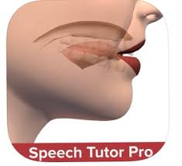 | $30.99 | 3-8yrs | Videos of speech sound production, tips for producing accurate sounds and includes basics tutorial.
Language Apps
App Name and Developer | Icon | Cost | Age range | Description
Keyword Kids  (Language and Learning Steps) |  | $38.99 | 2-8yrs | Supporting children's language development by increasing understanding of instructions through Key Words
Splingo’s Language Universe  (Speech &Lang St) |  | $4.49 | 2-5yrs | Splingo the alien’s spoken instructions will guide your child through a galaxy of language learning.
Fun with Directions  (Hamaguchi) |  | $14.99 | 2-5yrs | Fun and engaging way to practice listening, following directions, colours, spatial concepts, auditory memory.
WH Questions  (Super Duper) |  | Free | 3-6yrs | Learn how to correctly ask and answer WH questions with four entertaining learning games
Language Apps cont
App Name and Developer | Icon | Cost | Age range | Description
Key Verbs  (Language And Learning Steps) |  | $4.49 | 4-8yrs | Simple, fun, interactive action app, designed to teach a range of verbs and verb tenses
Fun with Verbs and Sentences  (Hamaguchi) | 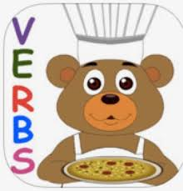 | $14.99 | 2-5yrs | Learning to speak in sentences, understand past and present verb tense, and formulate basic sentence structures.
First Phrases  (Hamaguchi) | 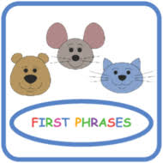 | $14.99 | 2-3yrs | Learning how to put two or three words together
Name That Category (Super Duper) | 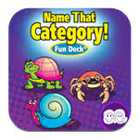 | $2.99 | 4-8yrs | Vocabulary app to practice describing, categorizing, and organizational skills.
Same/Different  (I CAN DO) | 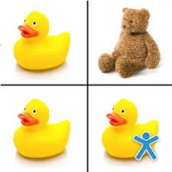 | $3.99 | 4+yrs | Vocabulary, categorization, develop visual discrimination and matching skills
Sentence Builder (Mobile Education) | 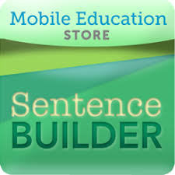 | $12.99 | 5-10yrs | Build grammatically correct sentences
Tense Builder  (Mobile Education) | 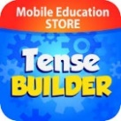 | $14.99 | 5-9yrs | Learn how to identify and use correct tense forms by playing movie quality animated videos to demonstrate past, present and future tense.
Rainbow Sentences  (Mobile Education) | 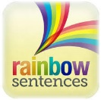 | $12.99 | 5-10yrs | Construct grammatically correct sentences by using color coded visual cues.
Story Builder  (Mobile Education) |  | $12.99 | 5-10yrs | Rich and fun environment for improving the ability to create a narrative.
Sentence Builder  (ABI Talk) |  | $9.99 | 5-10yrs | Learn about words, sentences, pronunciation, grammar, and punctuation.
Categories  (I CAN DO) | 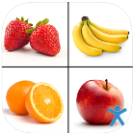 | $4.99 | 4+yrs | Listening skills, reading comprehension, vocabulary, reasoning and problem solving skills.
Toca Boca series |  | Free/up to $6 | 2-6yrs | Vocabulary and Talking skills  Top Picks: Kitchen Monsters, Tea Party, Hair Salon,
Preposition Pets  (Zorten Software) | 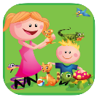 | $2.99 | 3-6yrs | Fun way to practice prepositions while playing the classic game of memory.
Pronouns with Splingo  (Speech and Lang St) | 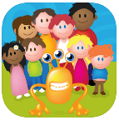 | $4.49 | 3-6yrs | Help teach the understanding and expressive use of a wide range of pronouns
Literacy Apps
App Name and Developer | Icon | Cost | Age range | Description
Oz Phonics 1-5  (DSP Learning) | 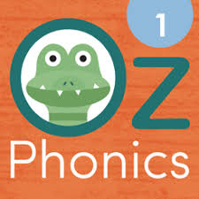 | $4.49 each  $14 bundles | 4-7yrs | Oz Phonics app series is Australian made, and designed to build students' literacy skills with a series of step-by-step exercises.
Out & About  (Dep of Ed) | 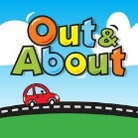 | Free | 4-7yrs | Practice sight words with this bright and fun app when you are out and about.
Little Learners Love Literacy  (Learning Logic) | 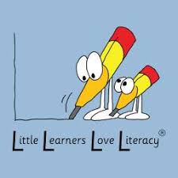 | Free L1  $6 L2-5  $8 L6-7 | 4-9yrs | Decodable readers with real stories about Tim and Pip and their adventures. Each book includes comprehension questions.
Spelling Magic 1, 2, 3, 4  (Pchool University) | 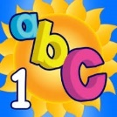 | $4.99 bundle | 4-7yrs | In this series, your child will learn to build and segment words
Little Stories Pro  (Little Bee Speech) | 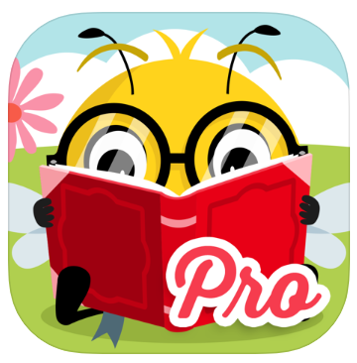 | $29.99 | 4-8yrs | Wonderful story-talk activities that help turn the reading experience into a mini book club.
Decodable Readers Australia | 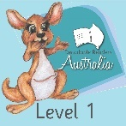 | $25.99 | 4-8yrs | Decodable Readers Australia books support a systematic approach of learning to read.
Teach Your Monster to Read  (Teacher Monster) |  | $4.49 | 3-6yrs | Children create a monster and take it on a magical journey over three extensive phonics and reading games
Vooks | 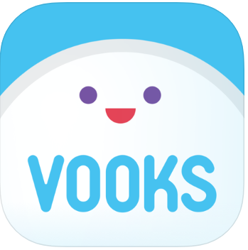 | $4.99/  month | 2-8yrs | A kid-safe, ad-free streaming library of read-aloud animated storybooks. 7 day free trial available.
Epic! Kids book and videos |  | $7.99/  month | 2-12yrs | Digital library for kids, 40,000 high-quality ebooks, audiobooks, learning videos, and quizzes for kids 12 and under.
Meet the Alphablocks  (Blue Zoo) | 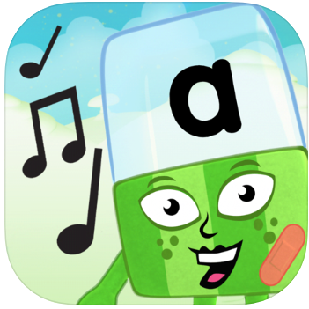 | Free | 3-6yrs | Get to know your alphabet and letter sounds and sing along to the Alphablocks song
Khan Academy Kids |  | Free | 3-8yrs | Award winning reading, language, writing, math, social-emotional development, problem-solving skills and more.

Social Skills Apps

App Name and Developer | Icon | Cost | Age range | Description
What Are They Thinking  (Super Duper) | 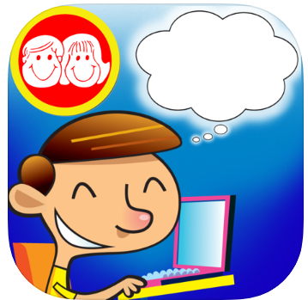 | $2.99 | 5-9yrs | Inferencing, reasoning, and conversational skills. All the people and animals have thought bubbles above their heads.
Conversation Builder  (Mobile Ed) | 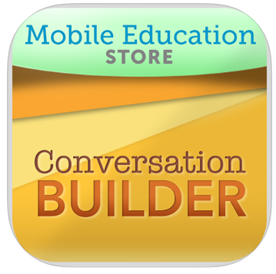 | $30.99 | 4-11yrs | Learn how to have multi-exchange conversations with their peers in a variety of social settings.
Emotions  (I CAN DO) |  | $7.99 | 4+yrs | Focuses on helping individuals identify different facial expressions using real faces and test their understanding of emotions.
Social Learning Platform  (EverydaySpeech) |  | Subscription  $300/yr | 4-adult | Hundreds of social skills videos and worksheet activities, online games.  30 free trial available. Links to website.
Kid in Story Book Maker  (Enuma Inc) | 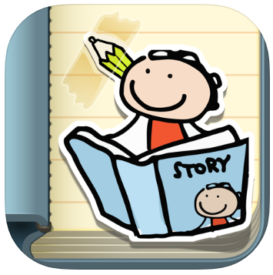 | $8.99 | 4-8yrs | Easy-to-make personalized stories can help boost social skills
Pictello  (Assistiveare) | 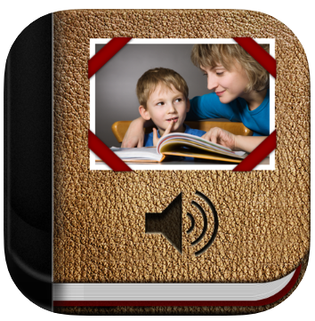 | $29.99 | All ages | Natural-sounding Text to Speech voices, or record your own voice, Pictello is the perfect tool for visual storytelling.

Behaviour Management Apps
App Name and Developer | Icon | Cost | Age range | Description
Choiceworks & Choiceworks Calendar  (Bee Visual) | 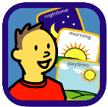 | $14.99 | 3-15yrs | Helping children complete daily routines, understand & control their feelings and waiting skills.  See also Choiceworks Calendar (new)
Token Board  (Zorten Software) | 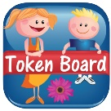 | $5.99 | 3-8yrs | Customizable tool for kids to track goals and earn rewards. Includes First-Then board
Guided Breathing with Jacob the Frog |  | $1.49 | 3-6yrs | Designed to help kids with anxiety focus on their breathing and calm themselves down.
Time Timer | 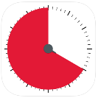 | Free |  | Ease transitions, establish routines and encourage more independence for kids.

